**Architecture Design**

**Excel Case Study**

**Revision Number - 1.1**

**Last Date of Revision - 18/08/2023**

**Rajat Sharma**

# Document Control

|  |  |  |  |  |
| --- | --- | --- | --- | --- |
| **Date** |  | **Version** | **Description** | **Author** |
| 16/08/2023 | 1.0 |  | Introduction,  Architecture,  Deployment | Rajat Sharma |
| 18/08/2023 | 1.1 |  | Final Revision | Rajat Sharma |

**Contents**

Document Version Control…………………………………………………………………………2

1. Introduction……………………………………………………………………………………….4
   1. What is Architecture Design Document?..............................................................4
   2. Scope……………………………………………………………………………………4
2. Architecture……….……………………………………………………………………….……...5
   1. Power BI Architecture………………………………………………………………….5
   2. Components of Power BI Architecture……………………………………………….6 3.

Deployment……….……………………………………………………………………….……...

7

* 1. Power BI Deployment………………………………………………………………….7
  2. Publish datasets and reports from Power BI Desktop………………………………7

# 1. Introduction

## 1.1 What is Architecture Design Document?

Any software needs the architectural design to represent the design of the software. IEEE defines architectural design as “the process of defining a collection of hardware and software components and their interfaces to establish the framework for the development of a computer system.” The software that is built for computer-based systems can exhibit one of these many architectures.

Each style will describe a system category that consists of:

* A set of components (eg: a database, computational modules) that will perform a function required by the system.
* The set of connectors will help in coordination, communication, and cooperation between the components.
* Conditions that how components can be integrated to form the system.
* Semantic models help the designer to understand the overall properties of the system.

**1.2 What is Scope?**

Architecture Design Document (ADD) is an architectural design process that follows a step-by-step refinement process. The process can be used for designing data structures, required software architecture, source code and ultimately, performance algorithms. Overall, the design principles may be defined during requirement analysis and then refined during architectural design work.

# 2. Architecture

## 2.1 Power BI Architecture

Power BI is a business suite that includes several technologies that work together. To deliver outstanding business intelligence solutions.

Microsoft Power BI technology consists of a group of components such as:

1. Power Query (for data mash-up and transformation)
2. Power BI Desktop (a companion development tool)
3. Power BI Mobile (for Android, iOS, Windows phones)
4. Power Pivot (for in-memory tabular data modelling)
5. Power View (for viewing data visualizations)
6. Power Map (for visualizing 3D geo-spatial data)
7. Power Q&A (for natural language Q&A)

In simple terms, a Power BI user takes data from various data sources such as files, Azure source, online services, Direct Query or gateway sources. Then, they work with that data on a client development tool such as Power BI Desktop. Here, the imported data is cleaned and transformed according to the user’s needs.

Once the data is transformed and formatted, it is ready to use in making visualizations in a report. A report is a collection of visualizations like graphs, charts, tables, filters, and slicers.



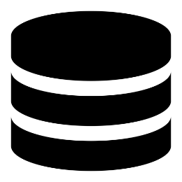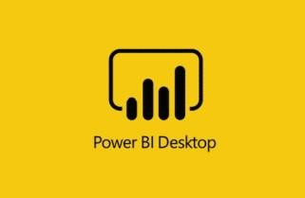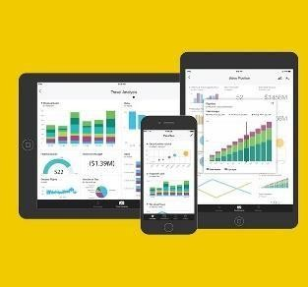

**Data Source**



**D**



**elivery**



### 2.2 Components of Power BI Architecture

#### 1. Data Sources

An important component of Power BI is its vast range of data sources. You can import data from files in your system, cloud-based online data sources or connect directly to live connections. If you import from data on-premise or online services there is a limit of 1 GB. Some commonly used data sources in Power BI are: a) Excel

1. Text/CSV
2. XML
3. JSON
4. Oracle Database
5. IBM DB2 Database
6. MySQL Database
7. PostgreSQL Database
8. Sybase Database
9. Teradata Database
10. SAP HANA Database
11. SAP Business Warehouse server
12. Amazon Redshift
13. Impala
14. Google Big Query (Beta)
15. Azure SQL Database
16. Salesforce Reports
17. Google Analytics
18. Facebook
19. GitHub

#### 2. Power BI Desktop

Power BI Desktop is a client-side tool known as a companion development and authoring tool.

This desktop-based software is loaded with tools and functionalities to connect to data sources, transform data, data modelling and create reports.

#### 3. Power BI Service

Power BI Service is a web-based platform from where you can share reports made on Power BI Desktop, collaborate with other users, and create dashboards. It is available in three versions:

* Free version
* Pro version
* Premium version

#### 4. Power BI Report Server

The Power BI Report Server is similar to the Power BI Service. The only difference between these two is that Power BI Report Server is an on-premise platform. It is used by organizations who do not want to publish their reports on the cloud and are concerned about the security of their data.

**3. Deployment**

## 3.1 Power BI Deployment

The deployment process lets you clone content from one stage in the pipeline to another, typically from development to test, and from test to production.

During deployment, Power BI copies the content from the current stage, into the target one. The connections between the copied items are kept during the copy process. Power BI also applies the configured deployment rules to the updated content in the target stage. Deploying content may take a while, depending on the number of items being deployed. During this time, you can navigate to other pages in the Power BI portal, but you cannot use the content in the target stage.

## 3.2 Publish datasets and reports from Power BI Desktop

When you publish a Power BI Desktop file to the Power BI service, you publish the data in the model to your Power BI workspace. The same is true for any reports you created in Report view. You’ll see a new dataset with the same name, and any reports in your Workspace navigator.

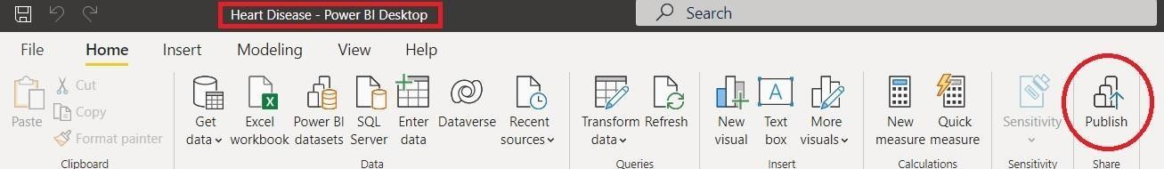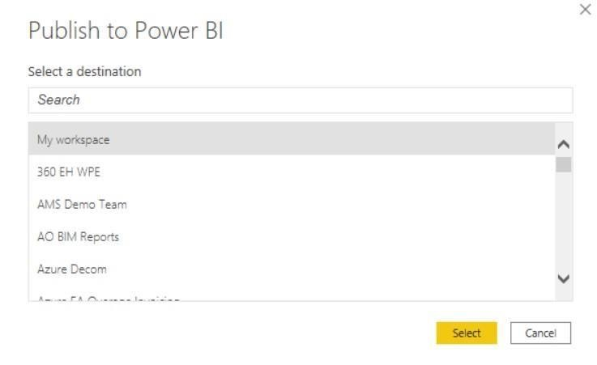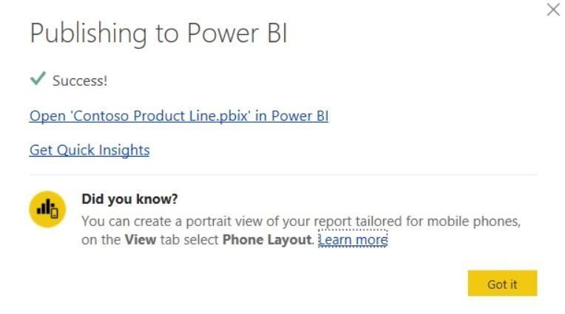

Publishing from Power BI Desktop has the same effect as using Get Data in Power BI to connect to and upload a Power BI Desktop file.